STAT301 Homework 2 Name Charles Sandahl
- The following data come from a study that examines the efficacy of saliva cotinine as an indicator for exposure to tobacco smoke. In one part of the study, seven subjects were each required to smoke a single cigarette. Samples of saliva were taken from all individuals 12 and 24 hours after smoking the cigarette and cotinine levels were recorded.
Individuals | Cotinine levels (nmol/l)  After 12 hours | Cotinine levels (nmol/l)  After 24 hours
1 | 73 | 24
2 | 58 | 27
3 | 67 | 49
4 | 93 | 59
5 | 33 | 0
6 | 18 | 11
7 | 47 | 43
Enter the data appropriately in R. Submit your R Markdown file. Perform an appropriate test to see if the mean cotinine levels after 12 hours is significantly higher than the mean cotinine level after 24 hours with 0.05 as the significance level.
Step 1: Formulate the null and alternative hypotheses using symbols
$$H_{0}:μ_{1}≤μ_{2} \\ H_{a}: μ_{1}>μ_{2}$$
Where $μ_{1}$is the mean of Cotinine levels at 12 hours and $μ_{2}$ the mean of Cotinine levels at 24 hours.

Step 2: Choose the one-tailed Paired T-test
Step 3: Find the test statistic and p-value from R
t = 4.1112, p-value = 0.003139
Step 4: Make a decision based to the null hypothesis; and explain the decision in the context

The p-value is 0.003, which is significantly lower than our $α$-value of 0.05 we reject the null hypothesis which suggests that there is evidence the mean cotinine levels are significantly higher at hour 12 than hour 24.

- The Bayley Scales of Infant Development yield scores on the Psychomotor Development Index (PDI). PDI can be used to assess a child’s level of functioning at approximately one year of age. As part of a study investigating the development status of children who had undergone reparative heart surgery during the first three months of life, the Bayley Scales were administered to a sample of one-year-old infants born with congenital heart disease. The children had been randomized to one of two different treatment groups, known as “circulatory arrest” (denoted as treatment group 0) and “low-flow bypass” (denoted as treatment group 1). The groups differed in the specific way in which the reparative surgery was performed. Unlike circulatory arrest, low-flow bypass maintains continuous circulation through the brain; although it is felt to be preferable by some physicians, it also has its own associated risk of brain injury. The data is on d2l (PDI score). Assume the two treatments have unequal variances. At the 0.05 level of significance, test the claim that the mean PDI score at one year of age for the circulatory arrest treatment group is significantly different from that for the low-flow group.
Step 1: Formulate the null and alternative hypotheses using symbols
$$H_{0}:μ_{1}= μ_{2} \\ H_{a}: μ_{1}≠ μ_{2}$$
Where $μ_{1}$ is group 0 and $μ_{2}$ is group 1.

Step 2: Choose the Two tailed independent T test
Step 3: Find the test statistic and p-value from R

t = -2.1715, p-value = 0.03158

Step 4: Make a decision to H0, and explain the decision in terms of the original claim.

The p-value is 0.03, which is significantly lower than our $α$-value of 0.05 we reject the null hypothesis which suggests that there is evidence the mean PDI score at one year of age for the circulatory arrest treatment group is significantly different from that for the low-flow group
Which group has a higher PDI score?
mean in group 0 mean in group 1
91.91781 97.60870
Group 1, the low flow bypass group has a higher mean PDI score.

- A camera has been developed to detect the presence of cataract more accurately. Using the camera, the gray level of each point in the lens of a human eye can be characterized into 256 gradations. To test the camera, photographs were taken of six randomly selected normal eyes and six randomly selected cataractous eyes from a different group of people so the data is not paired. The gray level of each eye was computed in the lens. The data are given in the following table. Use the 0.05 significance level to test the claim that the mean gray level from cataractous eyes is significantly lower than the mean gray level from normal eyes.
Cataractous gray level | Normal gray level
161 | 158
140 | 182
136 | 185
161 | 145
106 | 167
149 | 177
- Enter the data as one IV and one DV. Generate a point graph to plot the mean difference between cataractous eyes and normal eyes with error bars. Submit your R Markdown file.
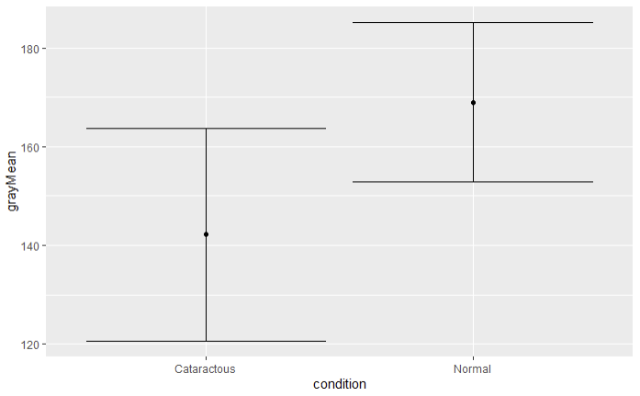
- Test the hypothesis in the question with the steps below:
Step 1: Formulate the null and alternative hypotheses using symbols
$$H_{0}:μ_{1}= μ_{2} \\ H_{a}: μ_{1}< μ_{2}$$
Where $μ_{1}$ is mean cataractous gray level and $μ_{2}$ is mean normal gray level.
Step 2: Choose the Two tailed independent t test
Step 3: Find the test statistic and p-value from R
t = -2.5597, p-value = 0.015
Step 4: Make a decision to H0, and explain the decision to address the original claim
The p-value is 0.015, which is significantly lower than our $α$-value of 0.05 we reject the null hypothesis which suggests that there is evidence the mean gray level from cataractous eyes is significantly lower than the mean gray level from normal eyes

- Data below lists the times required for randomly selected eight flights to taxi out for takeoff and the corresponding times required to taxi in after landing for the same flight. All eight flights are American Airlines from New York to Los Angeles. Use the significance level of 0.05 to test the claim that the average time to taxi in is different from the average time to taxi out.
Flight | 1 | 2 | 3 | 4 | 5 | 6 | 7 | 8
Taxi-out | 30 | 19 | 12 | 19 | 18 | 22 | 19 | 13
Taxi-in | 12 | 13 | 8 | 21 | 17 | 15 | 26 | 12
Step 1: State the null and alternative hypotheses using the correct symbols
$$H_{0}:μ_{1}= μ_{2} \\ H_{a}: μ_{1}≠ μ_{2}$$
Where $μ_{1}$ is the mean taxi in time and $μ_{2}$ is the mean taxi out time
Step 2: Choose the two tailed Paired t test
Step 3: Find the test statistic and p-value in R
t = 1.3401, p-value = 0.2221
Step 4: Make a decision to the null hypothesis; and explain the decision to address the original claim.
The p-value is 0.22, which is significantly lower than our $α$-value of 0.05 we fail to reject the null hypothesis which suggests that there is evidence the mean average time taxiing in is not different than the mean average time taxiing out

